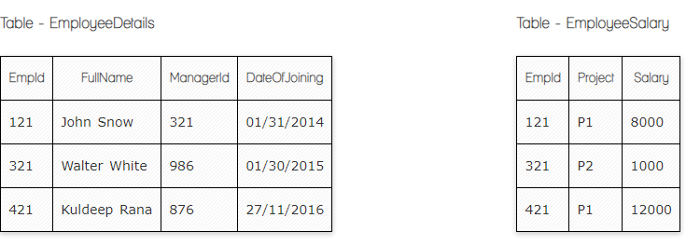

Write a SQL query to fetch employee names having salary greater than or equal to 5000 and less than or equal 10000.
Select * from EmployeeSalary
Inner Join EmployeeDetails
On EmployeeSalary.EmpId = EmployeeDetails.EmplID
Where Salary BETWEEN 5000 and 10000
Write a SQL query to fetch count of employees sorted by project's count in descending order.
Select count (Project)
From EmployeeSalary
Group by Project
Order by Project DESC
Write a query to fetch employee names and salary records. Return employee details even if the salary record is not present for the employee.
Select * from EmployeeSalary
Left Join EmployeeDetails
On EmployeeSalary.EmpId = EmployeeDetails.EmplID

